CSEC-472

Authentication and Security Models
Spring 2161

Implement SELinux Sandbox
Group Project (2 people)

Objectives: The objective of this project is to introduce students to SELinux. By the end of this project you should know how to setup a strict environment with user and service contexts. Additionally, students, should be able to identify the history and proper usage patterns for a deployment of SELinux within a secured environment.

Requirements: Students will study, investigate and implement Mandatory Access Control (MAC) and Role Based Access Control (RBAC) policies using a common framework provided by the Linux family of operating systems.

Objective 1: SELinux Deployment (Due week 8)
SELinux is a MAC based system that is designed to prevent a user who has gained a foothold on a system from being able to easily escalate privileges. By default modern SELinux provides ‘targeted’ policies for over 200 services, all other applications typically run under an ‘unconfined’ domain.

This restriction is wonderful if you have services that are being targeted but breaks down if you have an attacker that breaks in through another vector. Your task (if you choose to accept it) is going to be to develop an SELinux RBAC policy that will provide security in the following situation:

Defense Scenario (13 points)
You will be hosting three things - a webserver, a SQL server, and a custom C application.
Your web application should allow the following capabilities
- This application should be custom, that is, no Wordpress or Joomla.
- It should start on boot
- This web application should communicate with your database.
- It should clearly insert data into the database and present that data back to the user
- The design and functionality are up to you – it is only meant to serve as a flag (keep it simple).
- It should allow a user to upload a file and access it.
The C application should have the following capabilities:
- Run as SetUID
- Be accessible/executable by the user
- Take in a username
- Take in a password
- Print out the new username and password to stdout
- Change the username and password (if the user is privileged to do so)

Your system should be world accessible via SSH and you will provide the ‘root’ login and password to anyone. But you don’t want the system to be owned (compromised).

SELinux configuration (25 points)
Setup SELinux users, roles, domains, and policies such that this system will not allow root to do anything other than:
- Manipulate files in his home directory
- Run standard Linux applications (such as awk, ls, vim, etc)
- Compile and run C programs (‘build-essentials’ equivalent)
- And read logs.
This setup should deny access to sensitive Linux executables such as passwd and apachectl as well as deny access to sensitive folders (htdocs, etc) and files (etc/shadow, etc/password, config files, etc). You MAY not use any additional external security mechanisms (Containerization, lshell, etc) (If you have questions please reach out for clarification).

By the time you have completed this there should be no applications on your system that are not in a SELinux confined domain.

SELinux Configuration Option 1 (Full Credit):
You SHOULD be creating a new policy and role for this project. This means that you cannot just be use audit2allow or assign the guest_t/user_t roles. Yes, I understand this is more work, which is the point.

SELinux Configuration Option 2 (Maximum of 90% on this section):
An alternative acceptable approach is to use the restrictive guest_t role and manually relax the environment. Other approaches may be acceptable, please seek professor approval first!

Capture Logs: (6 points)
Earlier we discussed that users should be able to view logs. In addition to that you should also configure your SELinux logs to be pushed to a remote server you control and will maintain throughout the semester (if you need assistance allocating a machine for this ask the professor). Any method of achieving the aforementioned goal is acceptable, however syslog is probably the easiest.

UML Creation (6 points)
As part of this process you will provide root access to another student in the class who will attempt to elevate privileges with the end goal of defacing the webserver. This other student will also create a UML-like diagram of what he/she believes the permissions in question look like. In this section, generate the actual UML diagram for your system.
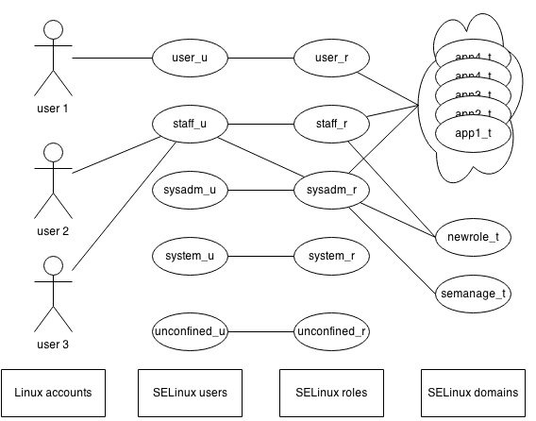
Figure 1: From https://wiki.gentoo.org/wiki/SELinux/Role-based_access_control

Writeup:
Deploy SELinux (on a VM) in a manner that is consistent with the description above. You may choose whichever Operating System you’d like for this project. It should be noted that some OS’s are more readily configured for this scenario. You will provide a report that outlines the following information:
- Why you chose your specific Operating System
- What the history of this operating system is (with special effort applied to access controls) hint: there should be some discussion of LSMs here.
- What the history of SELinux is as a whole and as it applies to your OS.
- A description of the commands you used to setup SELinux
- Any additional applications you needed or wanted to install
- What challenges you faced in setting up this environment
- Your UML Diagram
- Future work
- References

Video Evidence:
You should also include a video demonstrating your environment.
- Your video should be no longer than 10 minutes.
- It should show clearly that your protections work
- You should highlight any unique features/hacks you had to undertake
- You should clearly demonstrate that logging works as expected within this environment to attribute which user undertook activities that resulted in a violation of policy.
- You should also quickly show that you have your web application functional

Objective 2: Evaluations (Due week 12)

Grading Notes:
Note: If your webserver is defaced you may obtain no higher than a 90% on this project.
Note: If you compromise another team’s server you receive an automatic 100% for objective two.

Your team will be provided a VM by another team and you will likewise provide your VM to the other team. Your team matchups are specified on MyCourses. You will also provide this other team with root login credentials to your VM (and likewise).
Using the provided credentials your goal is to investigate (via HTTP and SSH) the SELinux deployment provided by the other team.
Your primary goal is to be able to deface this VM’s hosted web application. Your secondary goal is to perform actions that should be restricted or elevate privileges in some way.
You may not use ‘live-CDs’ or other attacks that would require having physical access, being given the distribution in VM format is just for convenience. Again, the primary goal is NOT to use web attacks to deface the web page, but rather investigate weaknesses in authentication policy. You may of course choose to try and test web attacks to leverage and note those in your report.
You should also use the information from your investigation to develop a UML diagram similar to the one generated in objective one for the target system.

You should provide a report that outlines the following:
- Executive Summary (3 points)
- Which attacks you undertook and their success level (15 points)
- UML Diagram of perceived SELinux setup (5 points)
- Any additional details about the SELinux setup that give a better idea about how it is setup (2 points)
- Conclusion (2 points)
- References (3 points)

Objective 3: Presentation (due weeks 14-15)

Your team will have half an hour (30 minutes) to present on three main themes. The first is the configuration of your environment and what challenges you faced. The second is what techniques you undertook to compromise (or try to compromise) the security of the webserver and how you generated a diagram of their environment. The last is a discussion of the activity you saw via your remote logging server. You should also discuss takeaways such as whether you believe this is an effective security solution, how it can be paired with existing/new technology, personal thoughts, etc.
Be sure to leave some time for questions.

Deliverables:
- Objective One
  - A report describing your environment (including UML)
  - A video highlighting your SELinux environment.
  - Your web application/C Application
  - Your SELinux policy file(s).
- Objective Two
  - A report describing any issues discovered in your audit of permissions
  - A diagram that describes your trust relationships using UML
- Objective Three
  - A half hour presentation

Due date: The presentations will be held during weeks 14-15.
Note: If a member of your team drops out during the course you are still responsible for all the work outlined

Grading Rubric for final Project
Item | Points
Objective One | 50
Objective Two | 30
Objective Three | 20
Total 100 points

